**Outline proposal for a systematic review**

# Are social outcomes of climate policies influenced by political economic contexts? A systematic map of the literature.

William F. Lamb1,2,*, Jan C. Minx1,2, Christian Flachsland1,3, Kilian Raiser1,3

1 Mercator Research Institute on Global Commons and Climate Change, Torgauer Straße 12–15, EUREF Campus #19, 10829 Berlin, Germany

2 School of Earth and Environment, University of Leeds, Leeds LS2 9JT, United Kingdom

3 Hertie School of Governance, Friedrichstraße 180, 10117 Berlin, Germany

* Corresponding author

## Abstract

Energy and climate change policies have wide-ranging social outcomes. These are potentially positive, in the case of recycling carbon tax revenues into public goods, or negative, when policies have distributional effects or hinder energy service access. We hypothesise that political economic contexts – such as the influence of interests, institutions or ideas – will determine the social character of climate policies. Our aim is to examine the literature on this question, using a systematic mapping methodology to collate and code the available evidence. Our synthesis will focus on the enabling and disabling contexts for achieving positive social outcomes from climate policies. We will further provide an overall assessment of what policies, contexts and outcomes have been studied, in order to set priorities for continued research in this field.

## Summary of evidence gap and research question

Climate change mitigation in line with the ambitions of the Paris Agreement will induce major shifts in energy supply and use (Allen *et al* 2018). This energy transition to net zero emissions, supported by low patterns of demand in end-use sectors, will have wide-ranging social outcomes. Positive outcomes might be gained through policies that funnel revenues into public goods, such as decentralised modern energy access, low-carbon mobility, or high quality energy efficient housing. Negative outcomes may arise when policies have a regressive character or fail to secure human needs, as is often (but not always) the case with fossil subsidy reform and energy price increases (Lockwood 2015, Frondel *et al* 2015, Dorband *et al* 2019).

We hypothesise that the direction of these outcomes will be decided in the political economy –broadly defined as the *interests*, *institutions* and *ideas* that together shape the adoption and content of reforms, often along pre-existing social and political fault lines. *Interests* might comprise incumbent energy providers, labour unions, and different social classes, each aiming to secure an advantage, but often through highly varied levels of access to political power (Fuchs *et al* 2015). Similarly, pre-existing *institutions* can determine the possibility space for policies, as for instance when governance arrangements are exposed to veto players that can unilaterally block reform (Lockwood *et al* 2016). Not least, the wider environment of *ideas* propagated in society – attitudes, norms, preferences – are highly determinant of action, such as the ubiquitous norm in Western societies against government intervention in deeply individual aspects of everyday life (Geels *et al* 2017).

There is a substantive literature on the political economy of energy transitions (Geels *et al* 2017, Sovacool and Hess 2017). There are also large literatures on social aspects of climate mitigation, including the distributional (income) implications of climate policy design (Dorband *et al* 2019), the linkages between human well-being and energy access (Lamb and Steinberger 2017, Brand-Correa *et al* 2018, Mattioli 2016, Rao and Min 2017), and emerging discussions on the role of welfare states in climate policy (Gough 2016, Koch and Fritz 2014). There is a clear gap and missing overview of where these two literatures meet, i.e. on how the social outcomes of climate policies are shaped by political economic contexts. Some review studies do address the political economy of specific epistemic concerns, such as energy poverty (Sovacool 2012), just transitions (Newell and Mulvaney 2013), and climate and development (Tanner and Allouche 2011). However, we do not find any cross-cutting reviews, nor any systematic reviews, even on individual issues[1].

The research question for this project is: *What evidence is there that political economic contexts influence the social outcomes of climate policies?* We define climate policies as any measure that lowers the carbon intensity of the energy system, or reduces overall energy demand (land-use and non-energy policies are excluded). We define social outcomes in terms of positive or negative distributional effects (i.e. on income), as well as shifts in access to modern energy services and mobility. Finally, we follow the literature on comparative political economy and define three elements of context that are critical for policy reform: the balance of social interests and stakeholders involved (such as incumbent energy providers, unions, political parties), the role of institutions (states, municipalities, governance arrangements), and the influence of prevailing ideas (preferences, attitudes, ideologies).

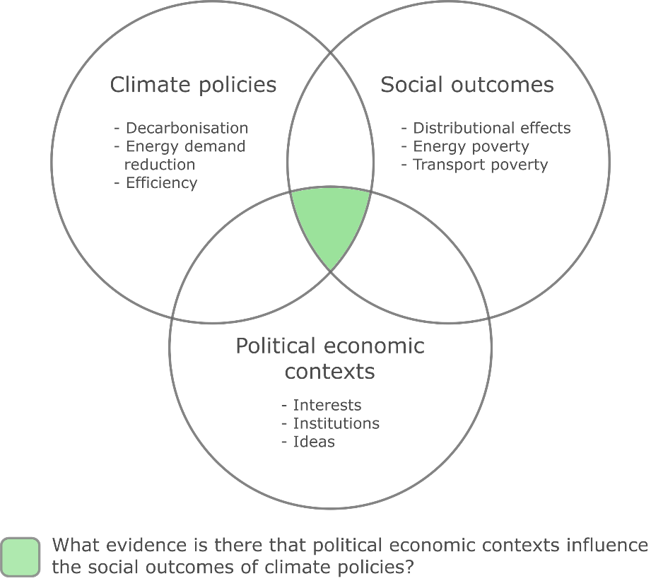

**Figure 1: Scope of the intended project**

Due to the broad scope, interdisciplinary and fragmented nature of the literature, this is review project will adopt a systematic mapping methodology (Haddaway *et al* 2016, James *et al* 2016). In short, we aim to identify the nature and extent of the literature base, with the following specific objectives:

* Identify the relevant studies using literature database searches and a call for evidence
* Characterise each study in terms of the examined: (1) climate policy; (2) social outcome(s); (3) political economic context(s)
* Characterise each study in terms of method (quantitative/qualitative), scale (national, urban, community-level) and epistemic community (discipline)
* Synthesize the results, focusing on research gaps and areas for consolidation, suggested policies, key drivers and barriers of reform, conceptual differences in political economy analysis

The window for meeting the goals set out in the Paris Agreement is rapidly closing. We perceive a strong need for this review, in light of currently missing but critically important short-term entry points to climate policy. At the same time, escalating social conflicts in both the global North and South underline the need to consider social objectives in the design of climate policy – and to identify the most promising strategies to see these through to adoption. Our review will inform stakeholders of the available options and the potential barriers they face; it will also provide an important foundation for continued work in this area.

## Summary of proposed methods

The systematic map will be produced in four stages, according to the predefined protocol shown in Figure 2. These are briefly described below.

### Stage 1: Scoping

In the first stage we will narrow the project definition, compile a list of key texts and keywords, and perform initial searches in the Web of Science and Scopus. The project team will review random samples of the literature, assessing the quality and consistency of the results, potentially iterating the scope and search query keywords.

### Stage 2: Search and screening

We will perform a full search on the following databases:

* Web of Science
* Scopus
* Google Scholar
* JStor
* PubMed

We will complement our literature search with a call for evidence, advertised through mailing lists, networks and social media.

In the screening stage, samples of articles will be reviewed by all project participants and cross-checked for consistency. After a common inclusion and exclusion criteria are agreed upon, the lead author will conduct the full screening.

Initial exclusions deemed out of scope for this study are:

* Mitigation policies related to land-use (e.g. agriculture, forestry, bioenergy)
* Social outcomes not captured in our typology (e.g. food, water, mental health)
* Studies on the ‘social cost of carbon’
* Mitigation measures that are not delivered through legislative processes (e.g. individual action, corporate social responsibility)

### 

**Figure 2: Protocol for the systematic map**

### Stage 3: Extract data

Information from the obtained studies will be systematically extracted and coded. A coding rubric will be developed with all authors and applied to a sample of papers, again to be cross-checked and verified before applied to the full document set.

Information to extract are primarily the studied policy, studied outcomes, and contextual factors. Meta-data on the articles will also be identified, such as study design, scale, location and method. Further attention may be given to barriers or suggested strategies, where these are identified.

### Stage 4: Synthesis

The depth of synthesis to be carried out is largely dependent on the scope of available information – for which no overview currently exists. At minimum we will assess the breadth of studied policies, contexts and locations, providing an assessment of literature gaps and potential areas for follow-up reviews. We would also aim to conduct a framework synthesis on the enabling and disabling contexts for positive social outcomes from climate policies.

## Expected outcomes

We anticipate a single article from this review. The core product of the article will be a systematic map database: a list of studies marked up with our coding rubric. This will enable a rapid extension of the project into more in-depth synthesis and follow-up projects, in the case of sufficient evidence on particular issues. For instance, this may include a synthesis of case studies on fossil fuel subsidy reform, with a focus on the design and implementation of social outcomes. However, in itself, the systematic map will be an important guide for priority setting and future research in this field.

## Preliminary search query

|  |  |  |
| --- | --- | --- |
| Climate policy | Social outcomes | Political economic contexts |
| (("climat*" OR "global warming" OR "CO2" OR "carbon" OR "GHG" OR "greenhouse gas" OR "energy") AND ("tax" OR "policy" OR "measure" OR "mitigation" OR "reduction" OR “reform”)) | (("poverty" OR "human need*" OR "well-being" OR "wellbeing" OR "welfare" OR "social") AND (“access” OR “impact” OR "outcome" OR "effect" OR "improv*" OR "decline*")) OR “progressive” OR “regressive” | ("politic*")  OR  ("interest*" OR "coalition*" OR "corporation*" OR "constituenc*" OR "voter*" OR "electorate" OR "stakeholder" OR "union*" OR "lobby*" OR "rent-seek*" OR "corporate power" OR "conflict" OR "resistance*" OR "contest*")  OR  ("institution*" OR "governance")  OR  ("discourse*" OR "norms" OR "ideolog*" OR "legitimac*" OR "neoliberalism" OR "governmentality" OR "liberalism" OR "populism" OR "acceptance" OR "acceptability" OR "priorities" OR "attitude*" OR "social license") |
| Exclusions  NOT TS = | | |

|  |  |  |
| --- | --- | --- |
| Climate policy | Social outcomes | Political economic contexts |
| (("climat*" OR "global warming" OR "CO2" OR "carbon" OR "GHG" OR "greenhouse gas" OR "energy") AND ("tax" OR "policy" OR "measure" OR "mitigation" OR "reduction" OR “reform”)) | (("poverty" OR "human need*" OR "well-being" OR "wellbeing" OR "welfare" OR "social") AND (“access” OR “impact” OR "outcome" OR "effect" OR "improv*" OR "decline*")) OR “progressive” OR “regressive” | ("politic*")  OR  ("interest*" OR "coalition*" OR "corporation*" OR "constituenc*" OR "voter*" OR "electorate" OR "stakeholder" OR "union*" OR "lobby*" OR "rent-seek*" OR "corporate power" OR "conflict" OR "resistance*" OR "contest*")  OR  ("institution*" OR "governance")  OR  ("discourse*" OR "norms" OR "ideolog*" OR "legitimac*" OR "neoliberalism" OR "governmentality" OR "liberalism" OR "populism" OR "acceptance" OR "acceptability" OR "priorities" OR "attitude*" OR "social license") |
| Exclusions  NOT TS = | | |

## References

Allen M, Babiker M, Chen Y, Coninck H de, Connors S, Diemen R van, Dube O P, Ebi K, Engelbrecht F, Ferrat M, Ford J, Forster P, Fuss S, Guillen T, Harold J, Hoegh-Guldberg O, Hourcade J-C, Huppmann D, Jacob D, Jiang K, Johansen T G, Kainuma M, Kleijne K de, Kriegler E, Ley D, Liverman D, Mahowald N, Masson-Delmotte V, Matthews R, Melcher R, Millar R, Mintenbeck K, Morelli A, Moufouma-Okia W, Mundaca L, Nicolai M, Okereke C, Pathak M, Payne A, Pidcock R, Pirani A, Poloczanska E, Pörtner H-O, Revi A, Riahi K, Roberts D C, Rogelj J, Roy J, Seneviratne S, Shukla P R, Skea J, Slade R, Shindell D, Singh C, Solecki W, Steg L, Taylor M, Tschakert P, Waisman H, Warren R, Zhai P and Zickfeld K 2018 Summary for Policymakers *Global Warming of 1.5oC: an IPCC special report on the impacts of global warming of 1.5oC above pre-industrial levels and related global greenhouse gas emissions pathways, in the context of strengthening the global response to the threat of climate change* (Cambridge, United Kingdom and New York, NY, USA: Cambridge University Press)

Brand-Correa L I, Martin-Ortega J and Steinberger J K 2018 Human Scale Energy Services: Untangling a “golden thread” *Energy Res. Soc. Sci.* **38** 178–87 Online: www.elsevier.com/locate/erss

Dorband I I, Jakob M, Kalkuhl M and Steckel J C 2019 Poverty and distributional effects of carbon pricing in low- and middle-income countries – A global comparative analysis *World Dev.* **115** 246–57

Frondel M, Sommer S and Vance C 2015 The burden of Germany’s energy transition: An empirical analysis of distributional effects *Econ. Anal. Policy* **45** 89–99 Online: http://dx.doi.org/10.1016/j.eap.2015.01.004

Fuchs D, Di Giulio A, Glaab K, Lorek S, Maniates M, Princen T and Røpke I 2015 Power: The missing element in sustainable consumption and absolute reductions research and action *J. Clean. Prod.* **132** 298–307 Online: http://linkinghub.elsevier.com/retrieve/pii/S0959652615001109

Geels F W, Sovacool B K, Schwanen T and Sorrell S 2017 The Socio-Technical Dynamics of Low-Carbon Transitions *Joule* 1–17 Online: http://linkinghub.elsevier.com/retrieve/pii/S2542435117300922

Gough I 2016 Welfare states and environmental states: a comparative analysis *Env. Polit.* **25** 24–47 Online: http://www.tandfonline.com/doi/full/10.1080/09644016.2015.1074382

Haddaway N R, Bernes C, Jonsson B G and Hedlund K 2016 The benefits of systematic mapping to evidence-based environmental management *Ambio* **45** 613–20

James K L, Randall N P and Haddaway N R 2016 A methodology for systematic mapping in environmental sciences *Environ. Evid.* **5** 1–13

Koch M and Fritz M 2014 Building the eco-social state: Do welfare regimes matter? *J. Soc. Policy* **43** 679–703

Lamb W F and Steinberger J K 2017 Human well-being and climate change mitigation *Wiley Interdiscip. Rev. Clim. Chang.* **8** 1–16

Lockwood M 2015 Fossil Fuel Subsidy Reform , Rent Management and Political Fragmentation in Developing Countries *New Polit. Econ.* **20** 475–94

Lockwood M, Kuzemko C, Mitchell C and Hoggett R 2016 Historical institutionalism and the politics of sustainable energy transitions : A research agenda

Mattioli G 2016 Transport needs in a climate-constrained world. A novel framework to reconcile social and environmental sustainability in transport *Energy Res. Soc. Sci.* **18** 118–28 Online: http://dx.doi.org/10.1016/j.erss.2016.03.025

Newell P and Mulvaney D 2013 The political economy of the “just transition” *Geogr. J.* **179** 132–40

Rao N D and Min J 2017 Decent Living Standards: material prerequisites for human wellbeing *Soc. Indic. Res.*

Sovacool B K 2012 The political economy of energy poverty: A review of key challenges *Energy Sustain. Dev.* **16** 272–82 Online: http://dx.doi.org/10.1016/j.esd.2012.05.006

Sovacool B K and Hess D J 2017 Ordering theories: Typologies and conceptual frameworks for sociotechnical change *Soc. Stud. Sci.* **47** 703–50

Tanner T and Allouche J 2011 Towards a New Political Economy of Climate Change and Development *IDS Bull.* **42** 1–14

1. Based on a Web of Science and Scopus topic search, refining by reviews, using the following keywords: (("climat*" OR "energy") AND ("wellbeing" OR "welfare" OR "social" OR "well-being" OR "poverty" OR "human need") AND ("political econom*"))